- Personal Data:
  - Name: Karim Zakaria Ahmed Soliman
  - Surname: Saloma

- File Description:
  - Launch Files
    - mapping_optitrack: start mapping nodes using optitrack odometry
    - mapping_visual_odom: start mapping nodes using visual odometry
    - mapping_visual_odom_imu: start mapping nodes using visual odometry and imu data
    - localization_amcl: start localization nodes using visual odometry, imu & amcl
  - Xml Files:
    - optitrack_gmapping.launch: gmapping configuration file for optitrack odometry
    - visual_odom_gmapping.launch: gmapping configuration file for visual odometry
    - robot_pose_ekf_imu.launch: robot pose ekf node configuration for odom-imu merge
    - amcl.launch: amcl node configuration for localization
  - Map Files:
    - optitrack_map: map created using optitrack odometry
    - camera_no_imu_map: map created using visual odometry
    - camera_imu_map: map created using visual odometry & imu data

- TF Tree Structure:
  - Mapping:
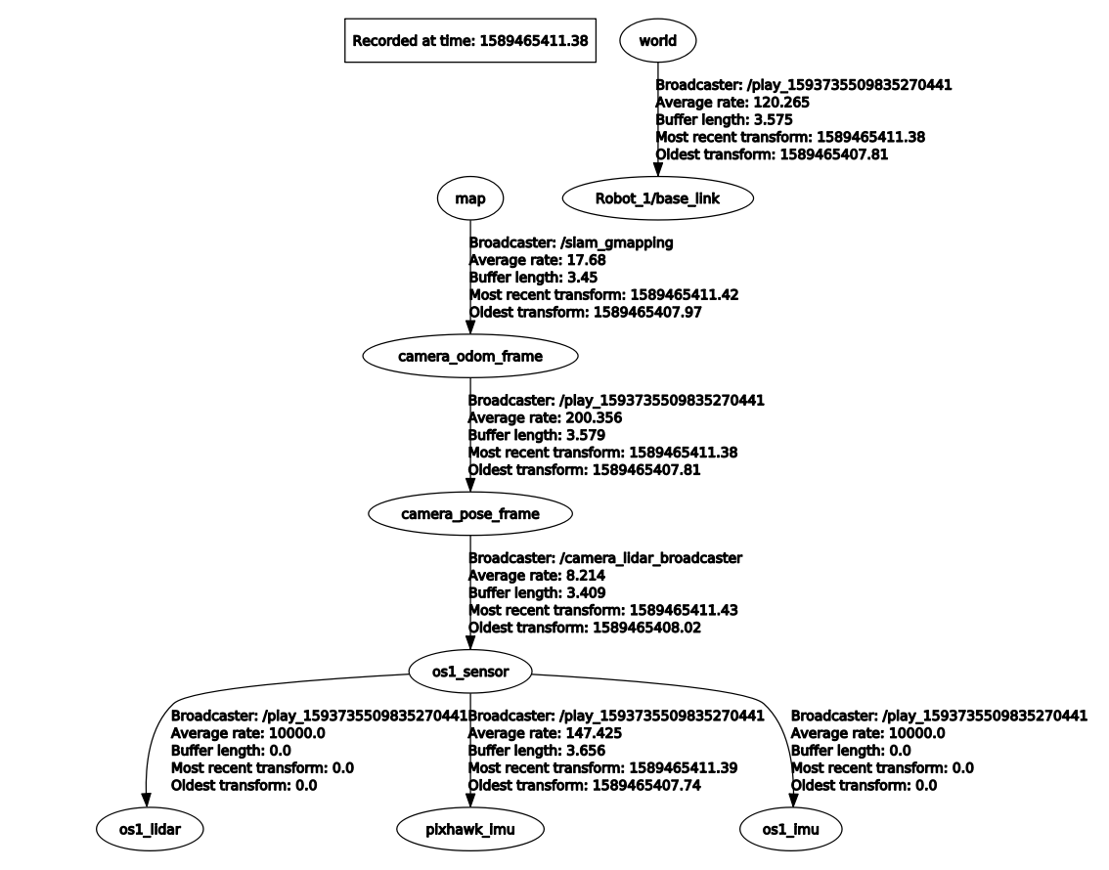
  - Localization:
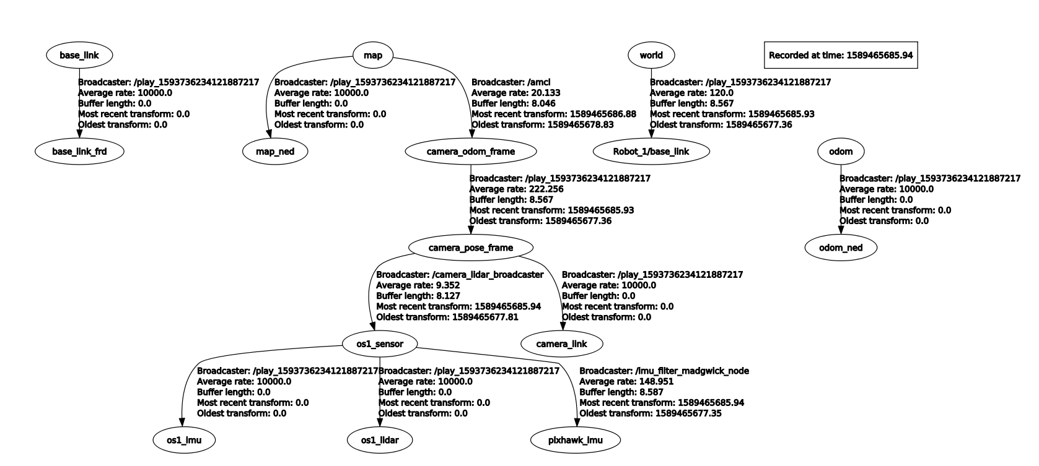

- Bag Choice:
  - Mapping: 2020-05-14-16-09-36-traj1-os1-t265-pix.bag
  - Localization: 2020-05-14-16-14-37-traj2-os1-t265-pix.bag

- Node Usage:
  - Mapping: Start node using one of the three launch files for mapping then play the rosbag with the (--clock) option to publish with sim time, finally, use mapserver to save map.
  - Localization: Use the localization launch file then start the bag also with (--clock).

- General Choices:
  - I opted for the use the of robot pose ekf rather than the robot localization package since it had a simpler interface for the incorporation of visual odometry particularly. Moreover, I tested the usage of visual odom, optitrack odom & imu data simultaneously but the results didn’t have a major improvement due to the addition of optitrack odom.

